Disney-Marvel Transaction
Terms of deal: Disney (NYSE:DIS) announced on 8/31/2009 that it would acquire Marvel Entertainment, Inc (NYSE:MVL) in a stock and cash transaction worth 4 billion dollars.
Industry Classification
Marvel is in the Services Sector, Movie Production/Theaters Industry. 300 F/T employees.
Disney is in the Services Sector, Entertainment-Diversified Industry. 150,000 F/T employees.
Movie Production/Theaters Industry Statistics
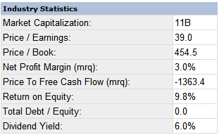
Entertainment-Diversified Industry Statistics
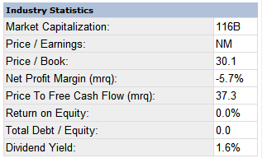
Transaction Price: Disney offered Marvel shareholders $30 per share in cash, plus approximately 0.745 Disney shares for each Marvel share they own. Based on the closing price of Disney stock on Friday, August 28, the transaction value is $50 per Marvel share or approximately $4 billion.
Reasons for the Deal:
For Disney: What makes this deal huge, as far as content goes, is the fact that under the terms of the deal, Disney will acquire ownership of not only Marvel itself, but also over than 5,000 Marvel characters. Disney will now benefit from any movie or a game based on characters such as Iron Man, Spider-Man, X-Men and many others; extending its reach to the young male population it had somewhat neglected will definitely be good for the entertainment giant.
Ike Perlmutter, Marvel’s Chief Executive Officer said that “Disney is the perfect home for Marvel’s fantastic library of characters given its proven ability to expand content creation and licensing businesses.”
“This transaction combines Marvel’s strong global brand and world-renowned library of characters including Iron Man, Spider-Man, X-Men, Captain America, Fantastic Four and Thor with Disney’s creative skills, unparalleled global portfolio of entertainment properties, and a business structure that maximizes the value of creative properties across multiple platforms and territories,” said Robert A. Iger, President and Chief Executive Officer of The Walt Disney Company.
For Marvel:
As can be seen from the historical stock price charts below, this was a good deal for Marvel. Marvel was trading at around $38/share prior to the announcement and jumped to nearly $50, a 29% premium. Marvel Entertainment, Inc. includes three segments: Licensing, Publishing and Film Production. See summary below (from http://finance.yahoo.com/q/pr?s=MVL)

Marvel Entertainment, Inc. and its subsidiaries engage in the licensing, publishing, and film production businesses with a proprietary library of approximately 5,000 characters in the United States and internationally. Its library of characters include Spider-Man, Iron Man, The Incredible Hulk, Captain America, Thor, The Avengers, Ghost Rider, The Fantastic Four, X-Men, Blade, Daredevil, The Punisher, Namor the Sub-Mariner, Nick Fury, Silver Surfer, and Ant-Man. The company operates in three segments: Licensing, Publishing, and Film Production. The Licensing segment licenses its characters for use in various consumer products, including toys, apparel, games, electronics, homewares, stationery, gifts and novelties, footwear, food and beverages, and collectibles; feature films; television programs; DVD animated feature films; theme parks, shopping malls, and special events; promotions; and publications. The Publishing segment creates, publishes, and distributes comic books and trade paperbacks to the direct market and the mass market through comic book specialty stores and retail outlets, including bookstores and newsstands, as well as on a subscription basis. The Film Production segment develops, produces, and distributes films. It also provides preproduction services, including developing film concepts and screenplays, preparing budgets and production schedules, and obtaining production insurance and completion bonds. Marvel Entertainment, Inc. has joint venture interests in Spider-Man Merchandising L.P. The company was founded in 1988 and is based in New York, New York.
Marvel Valuation On 8/31/2009 the share price, number of shares outstanding and computed market cap are shown in the table below. Sources: http://finance.yahoo.com/q/ks?s=dis, http://finance.yahoo.com/q/ks?s=mvl
Company | Share Price (as of 8/31/2009) | Shares Outstanding | Computed Market Cap ($ bn)
Marvel Entertainment | $38/share | 78.02 million | $2.965
Disney | $26/share | 1.86 billion | $48.360

Disney offered $30/share in cash, or $2,240 million. (Where will Disney get this cash? According to the latest balance sheet data available, Disney has 3,860 million of cash and cash equivalents on hand, so can potentially afford this. http://finance.yahoo.com/q/bs?s=DIS) Disney also offered 0.745 shares of Disney per Marvel share. Since Disney was trading at $26/share, and there were 78.02 Marvel shares outstanding, this is equivalent to .745*26*78.02 = $1,511 million so the deal totaled $2,240 cash + $1,511 stock = $3,740 million or about $4 billion.
Historical Stock Prices
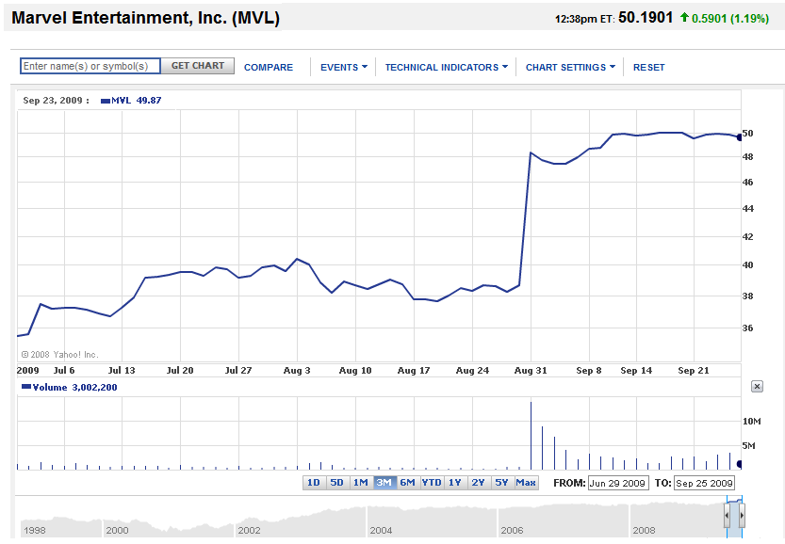
Disney
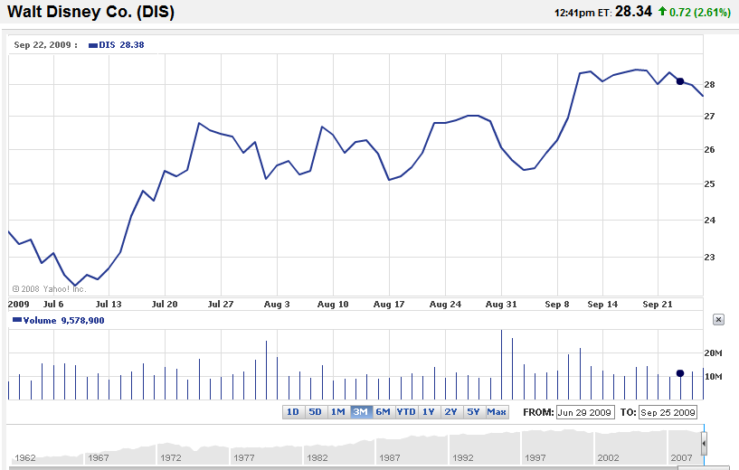
Questions:
- Why did Disney pay such a high premium for Marvel?
- How should Marvel be valued and why?
- Why was the deal structured as it was? (why not debt, why was cash offered, etc)
- What synergies do you think Disney expects to justify the premium paid?
- Value Marvel on the basis of:
  - P/E basis
  - EV/EBITDA
  - Average P/E multiples for the sector (See accompanying spreadsheet “726conameu.xls” for Industry/Sector data.)
- Do you think this was a good transaction for Disney and marvel and why?
- What trends do you see in this industry?
Does this deal make sense? http://www.fool.com/investing/general/2009/09/01/roundtable-is-the-disney-marvel-deal-a-winner.aspx
“The Disney/Marvel Marriage: Will They Live Happily Ever After?” (9/16/2009)
http://knowledge.wharton.upenn.edu/article.cfm?articleid=2337
Key Statistics for Marvel (as of 9/28/2009, current stock price is $50.12)
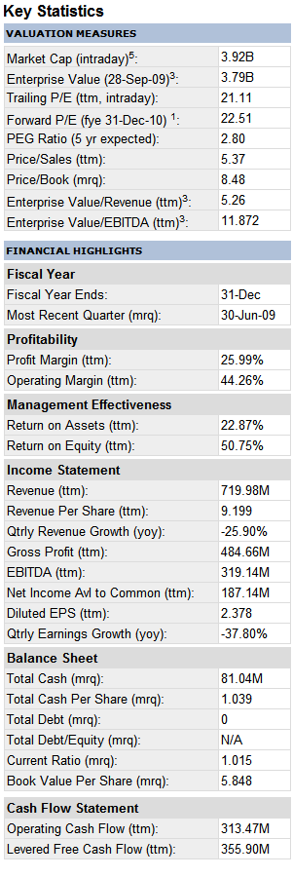
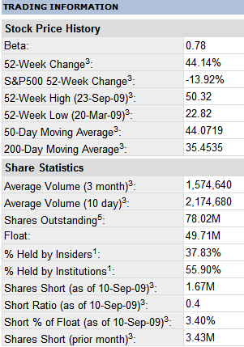
DISNEY

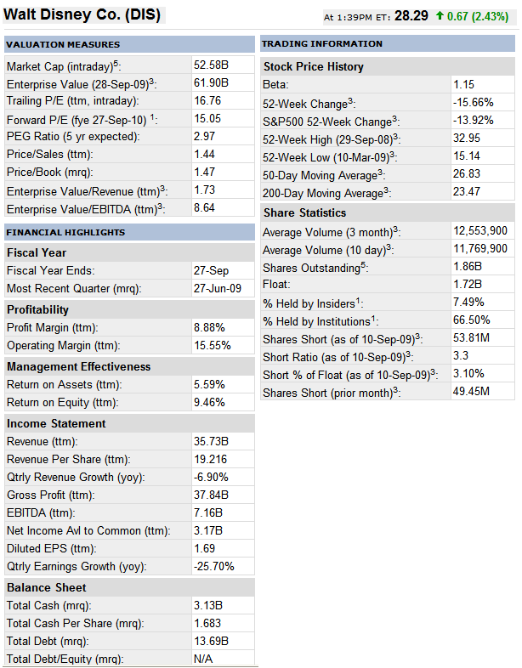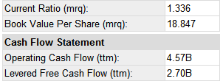
References
“DISNEY TO ACQUIRE MARVEL ENTERTAINMENT“, http://corporate.disney.go.com/news/corporate/2009/2009_0831_disney_and_marvel_entertainment.html

